V-Electronics: Revolutionizing Smart Device Management

**Phase 8: Data Management & Deployment**

This phase dealt with handling **large data volumes** and deploying configurations from one Salesforce environment to another.

**1. Introduction**

Salesforce projects rely heavily on smooth data management for migration, backup, and quality. Similarly, deploying metadata across sandboxes and production requires standardized tools.

**2. Objectives**

* To migrate and cleanse data securely.
* To ensure proper deployment processes across environments.
* To establish backup and restore mechanisms.

**3. Detailed Description of Contents**

**Data Import Wizard**

* Imported small data sets like customer lists and product catalogs.

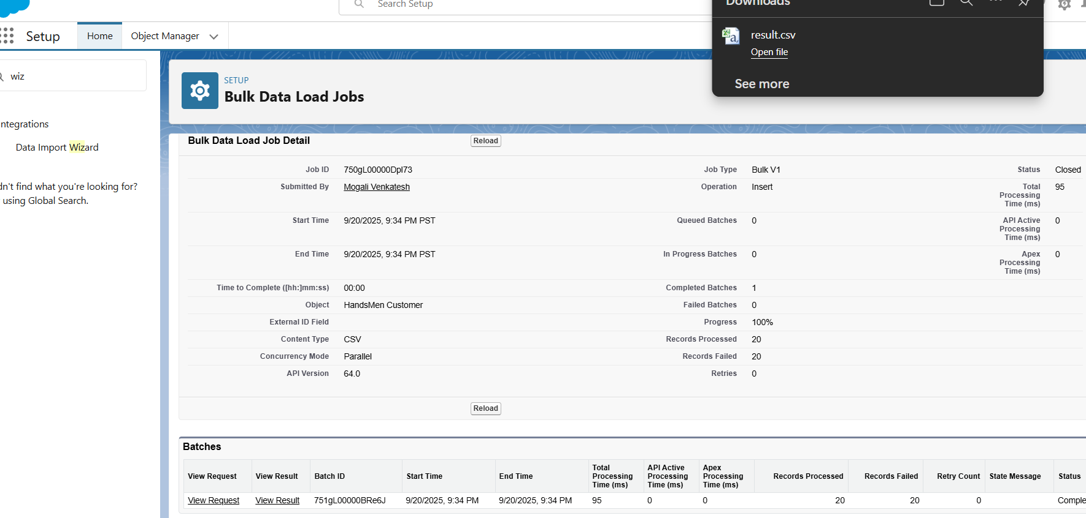

**Data Loader**

* Used for bulk data operations (e.g., migrating 50,000+ order records).

**Duplicate Rules**

* Created rules to prevent duplicate customers (by phone/email).

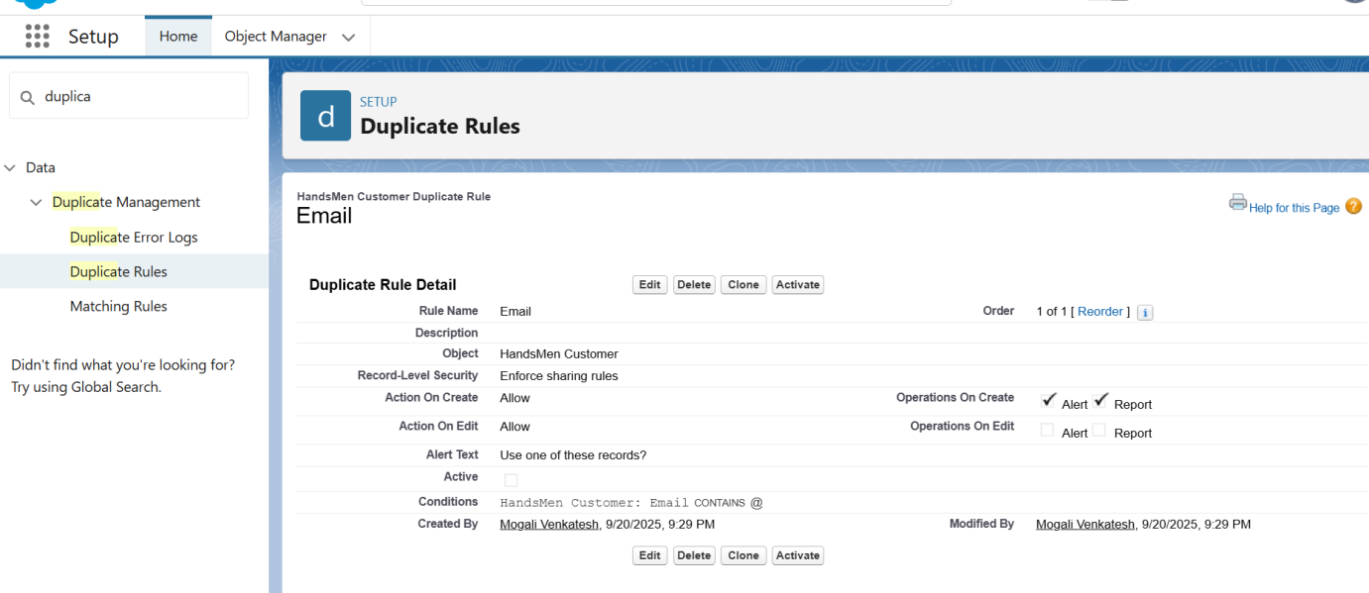

**Data Export & Backup**

* Scheduled weekly data exports for backup.

**Change Sets**

* Deployed customizations between sandboxes and production.

**Unmanaged vs Managed Packages**

* Used unmanaged packages during dev phase; explored managed packages for AppExchange..

**4. Deliverables**

* Clean and consistent datasets.
* Sandbox-to-production deployments with change sets and SFDX.
* Backup mechanisms ensuring data recovery.

**5. Conclusion**

This phase strengthened **data governance** and ensured smooth transitions from development to production environments.